**Team name: Fortis**

https://github.com/iuthub/design-project-fortis

bbset.000webhostapp.com

**Members:**

Murodillo Ismatov u1610159

Obbosxon Ruzimatov u1610172

Rasul Yakhyaev u1610262

Otabek Allanazarov u1610174

Abdulmalik Mamirov u1610007

Project name: **MyHotel (hotel management)**

Used languages, technologies, frameworks:

HTML5, CSS3, Javascript, JQuery, Php (Laravel), Bootstrap, Maps API, Fontawesome icons.

**FRONTEND description:**

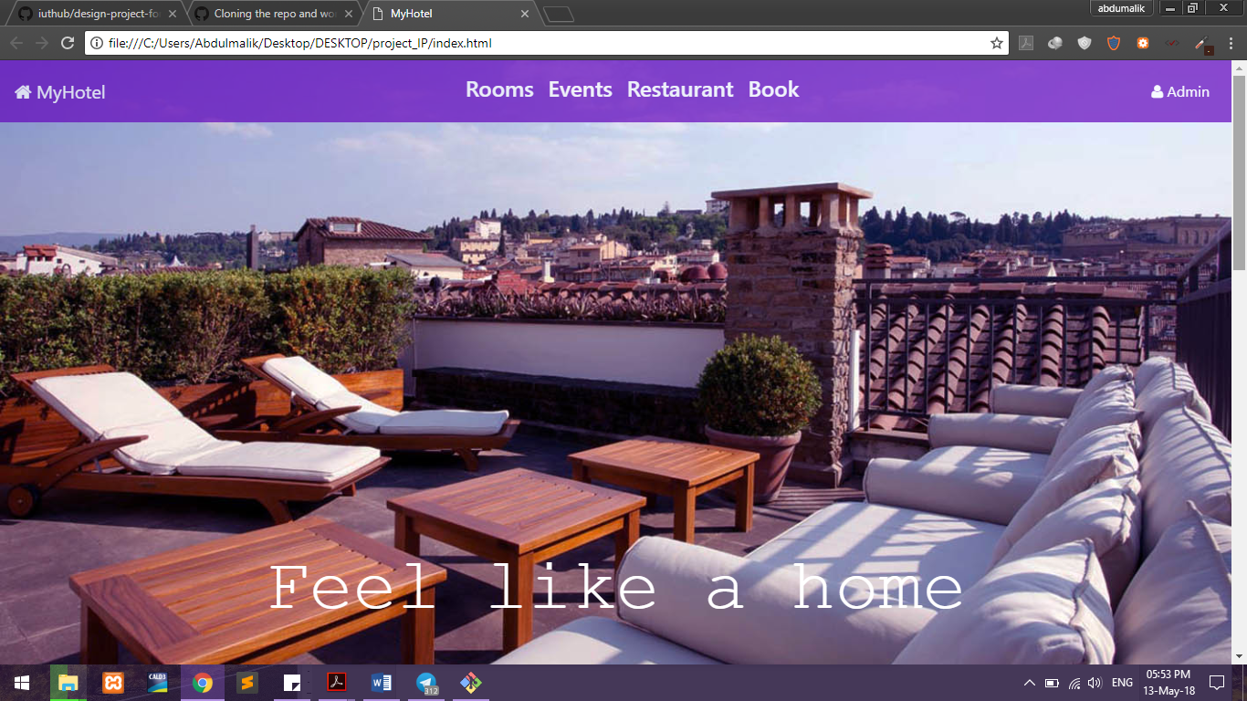

Index page we used Navbar of bootstrap and edit. Jquery and bootstrap carousels .

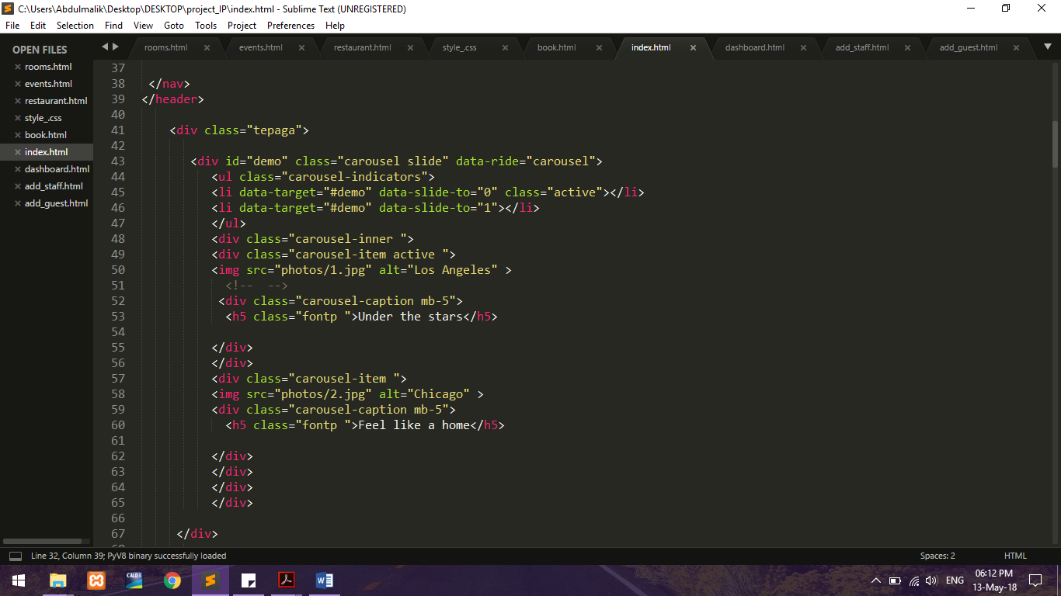

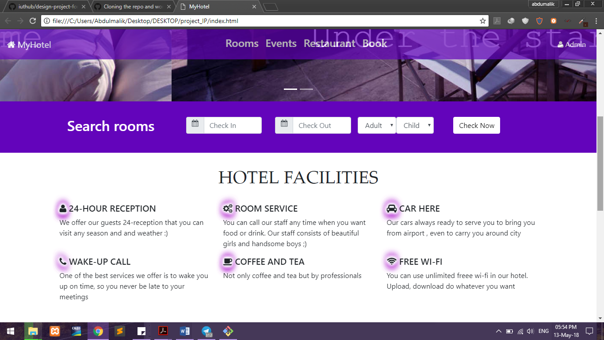

Here you can see Checking, and hotel facilities. Fontawesome icons used by us here. And given blink using css3 animation. Bootstrap Date picker also included.

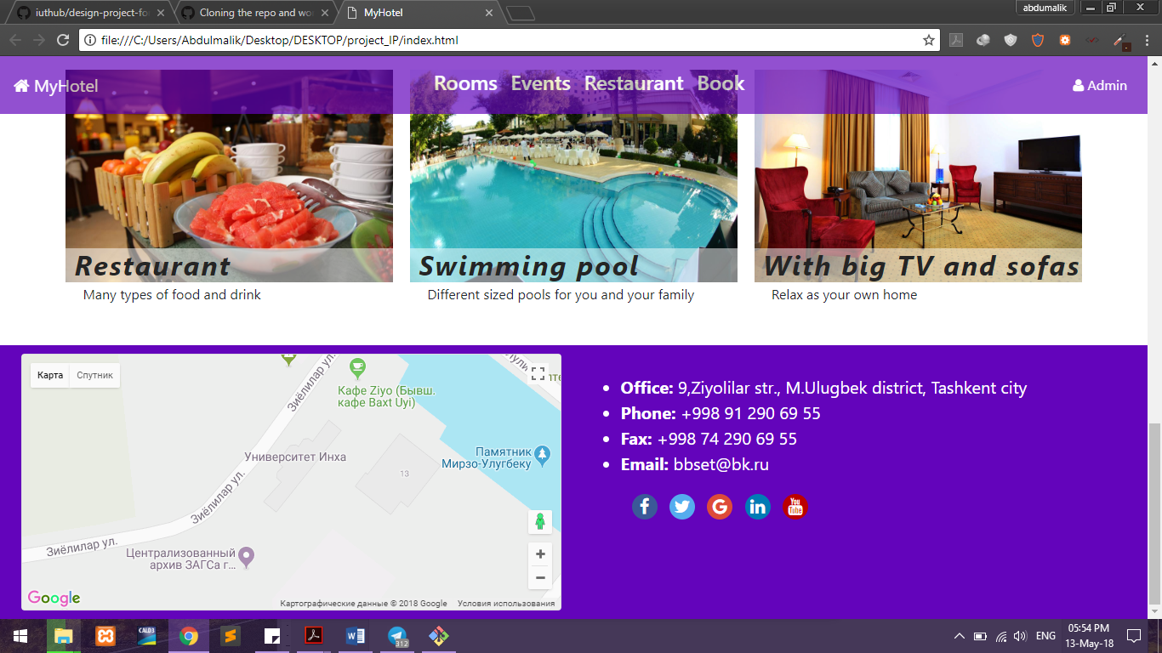

Jquery carousel is used here to give some view.

We made footer HTML5 tag, and used bootstrap grid system to make double column. First one is busy with Google maps and second is contact info.

We got Google maps API free keys and used it here.

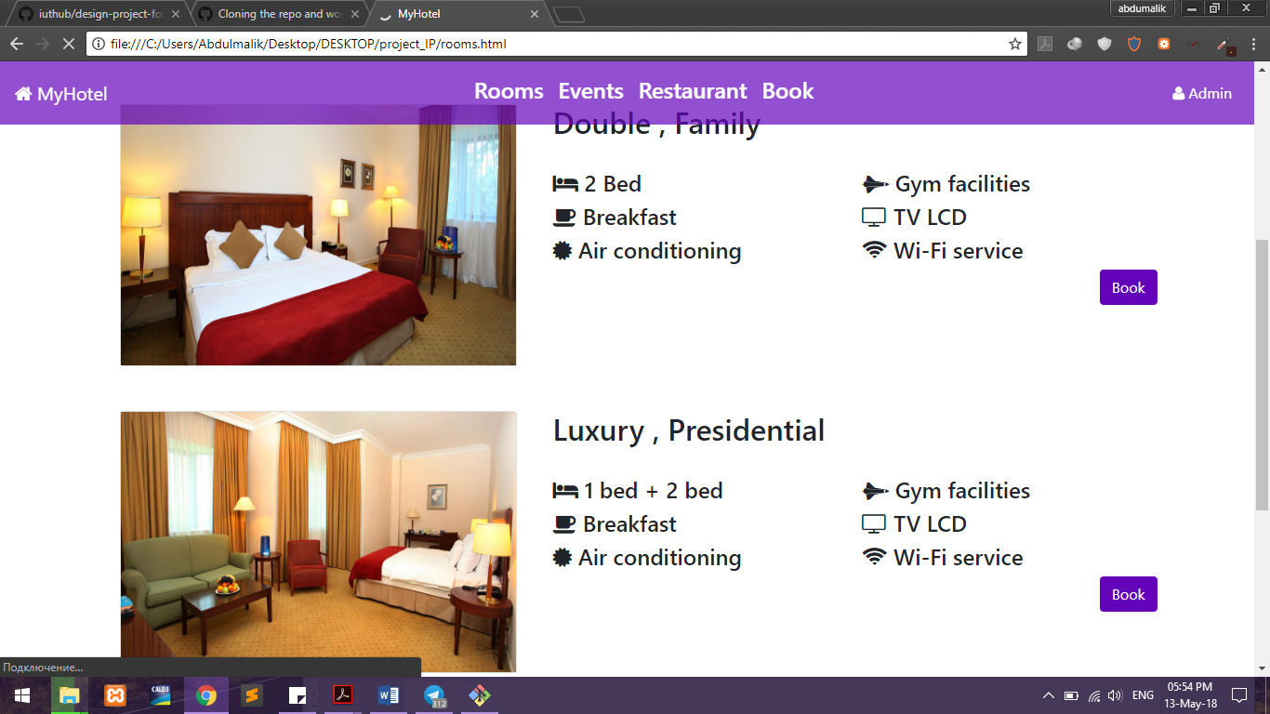

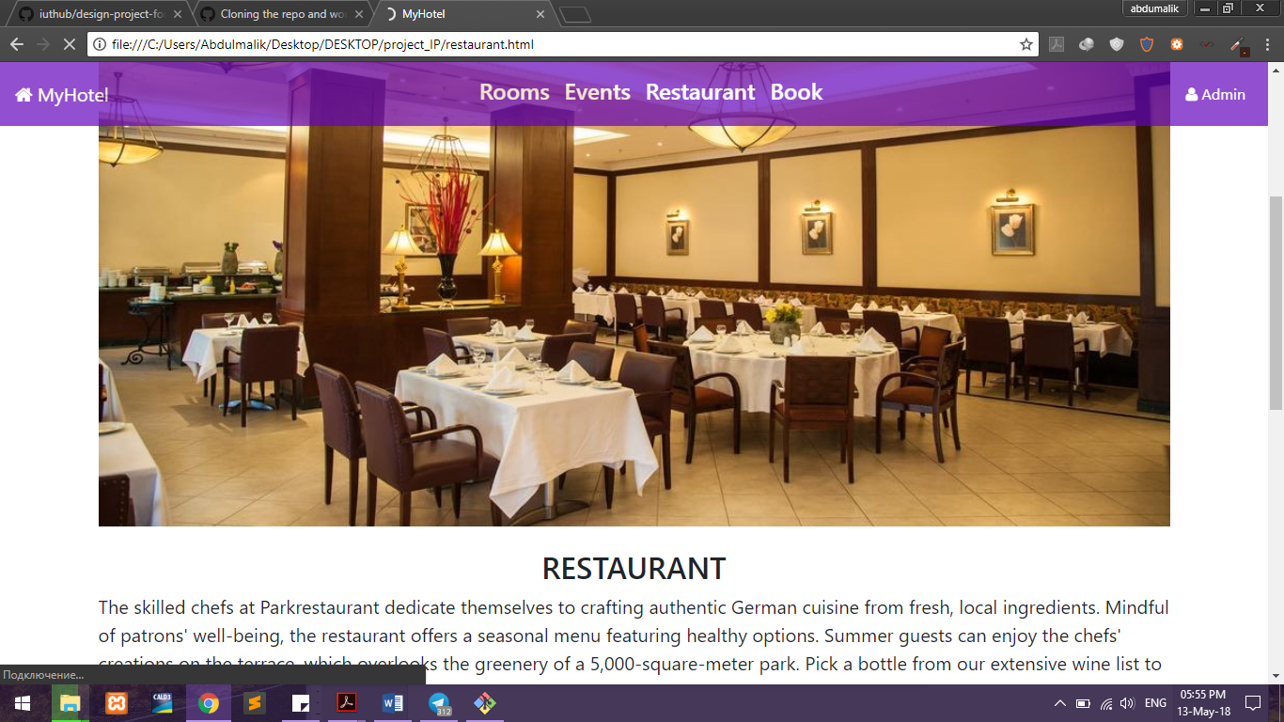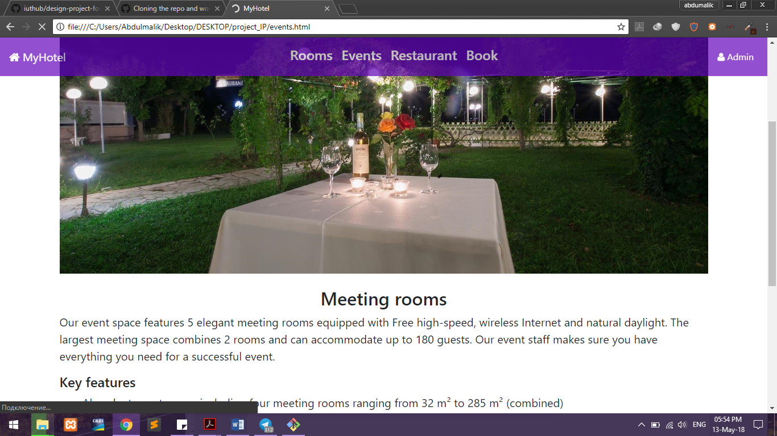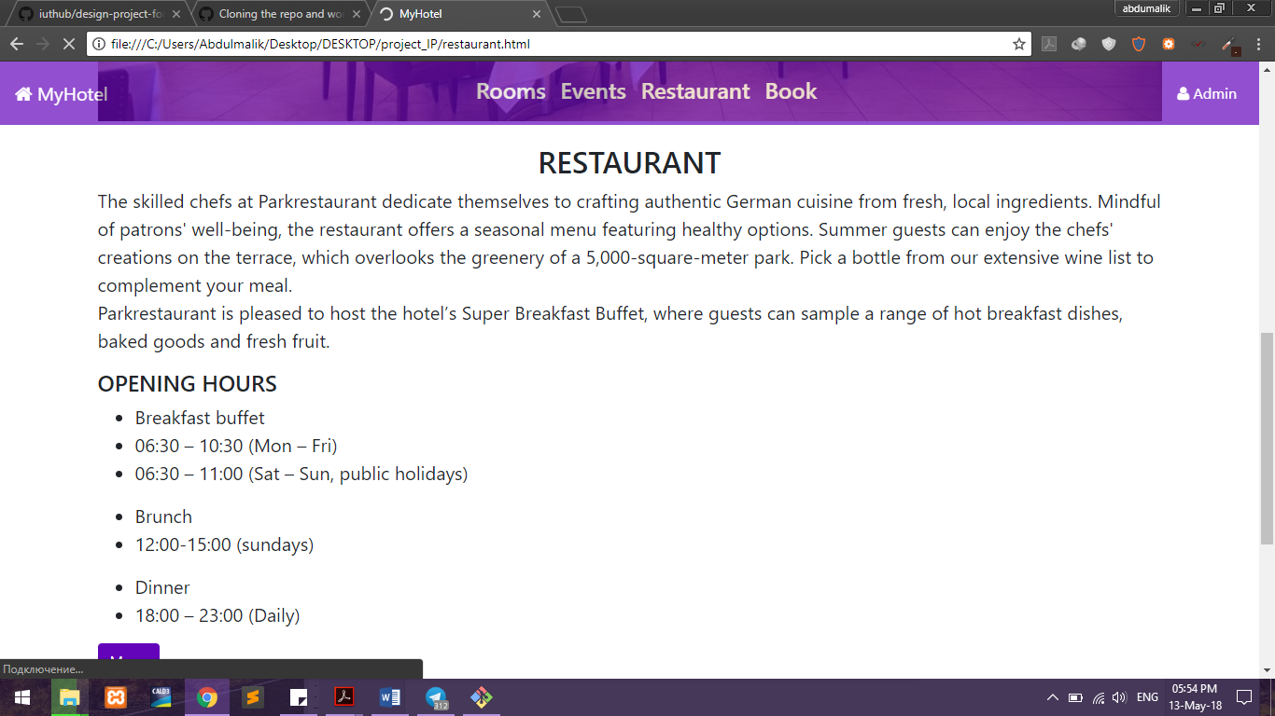

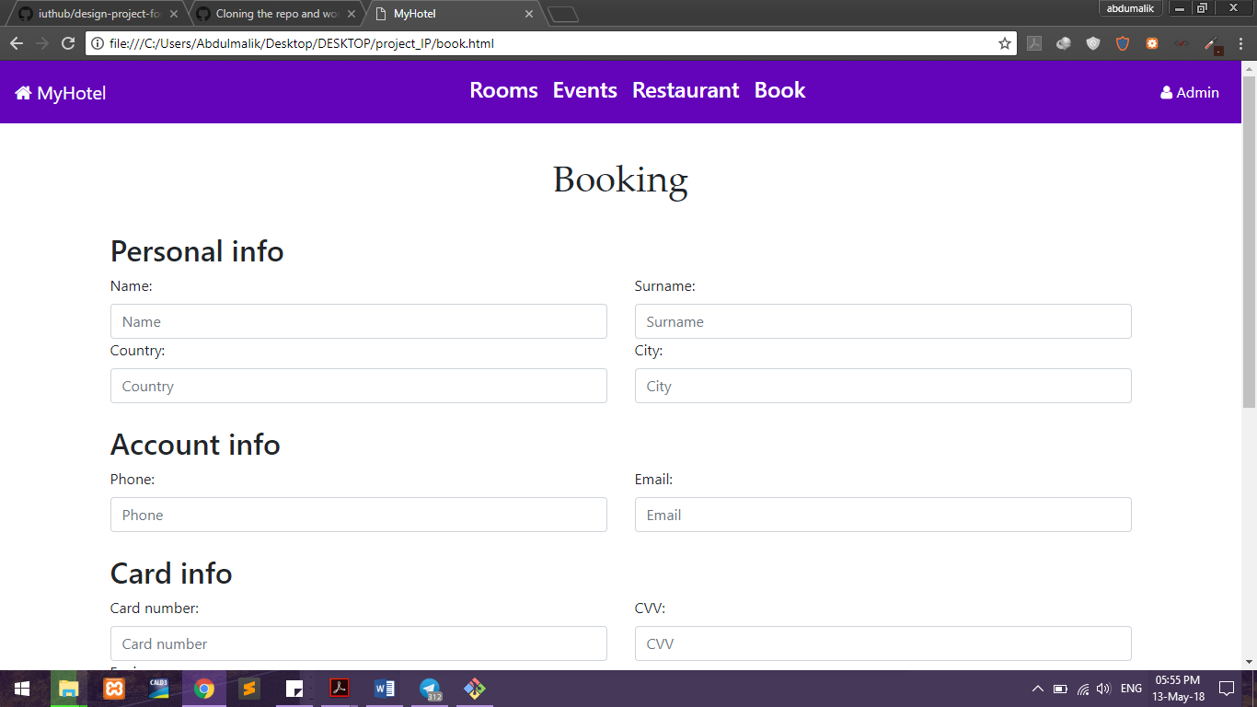

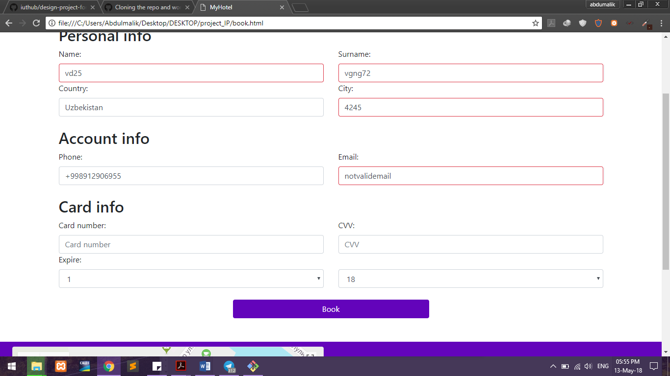

In the booking system here used both front end and backend validation. Front end validation done used Javascript, regex : email, card number, phone numbers and names

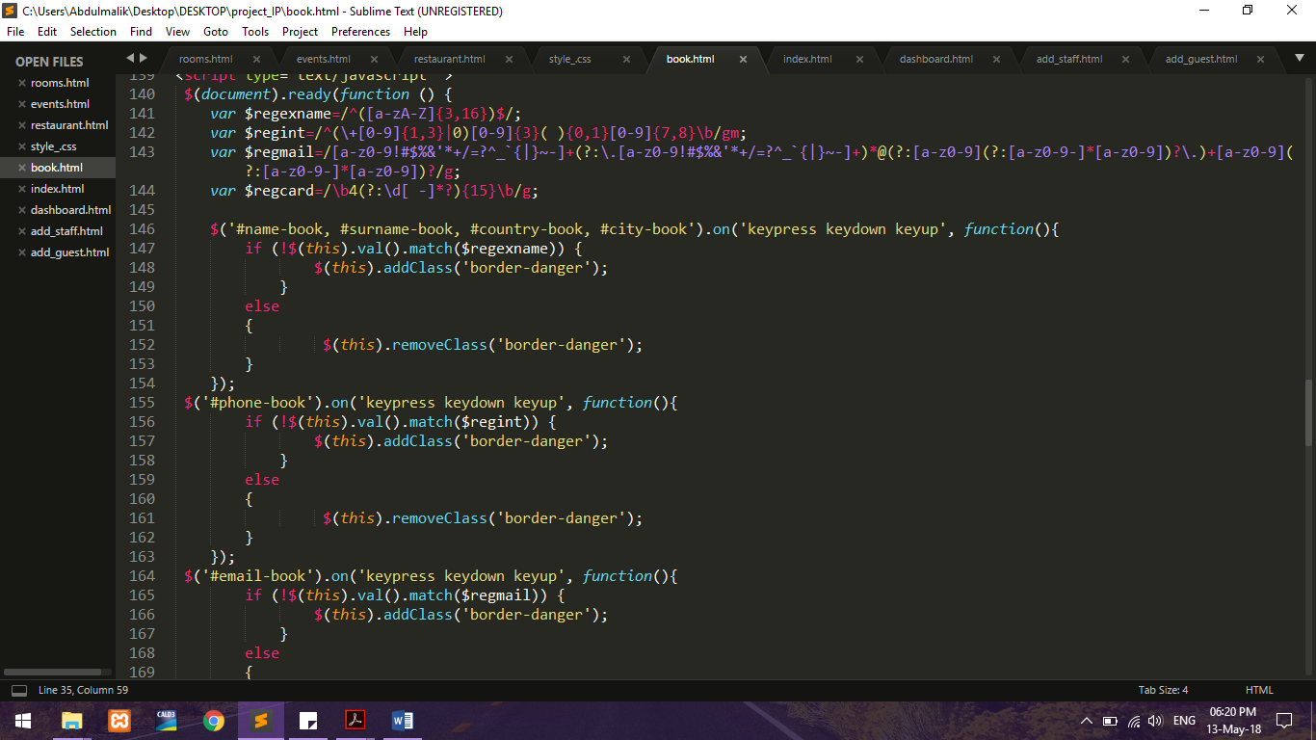

Login page is done used bootstrap cards.

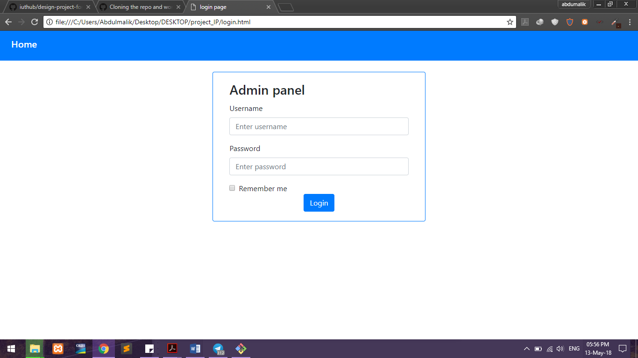

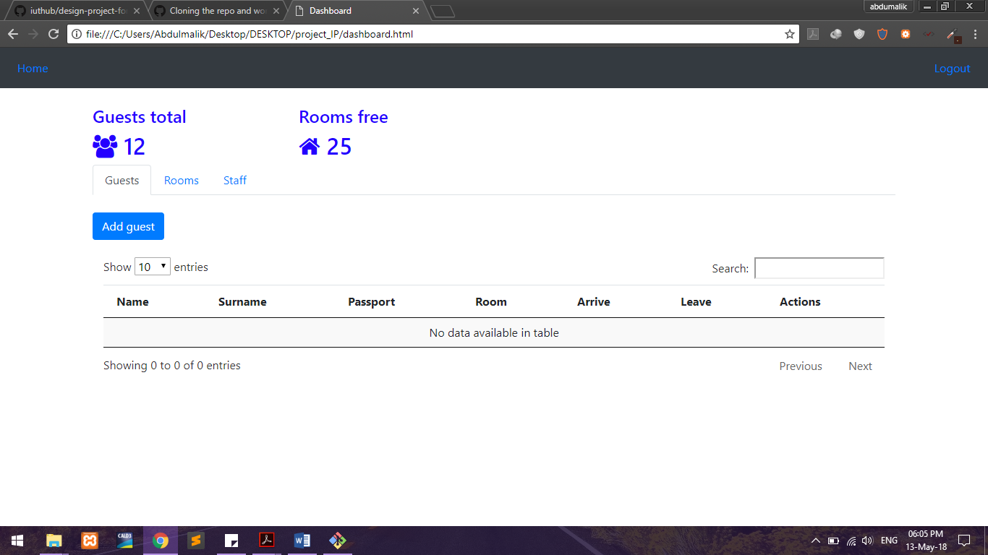

For controlling admin page (dashboard) we used datatables.js and .css and bootstrap .

Mainly used technology is bootstrap.

**Back-end** description:

In back end section, we use Laravel 5.5 framework and MySQL database.

you can see > this is **web.php**

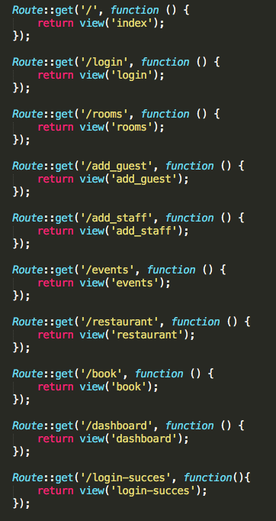

it will control get and post Routes

every details of website should be located proper folder:

This is resources folder which contain with php and html files

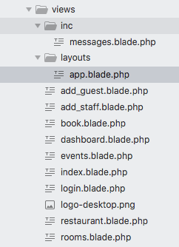

in public folder, there are css photo and javascript folders

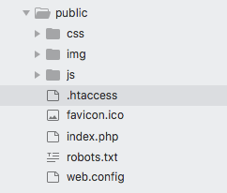

in database folder, there are tables which is called migrate in laravel

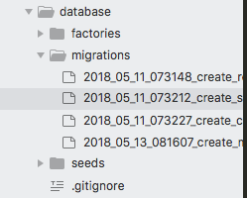

there are php files

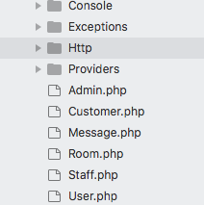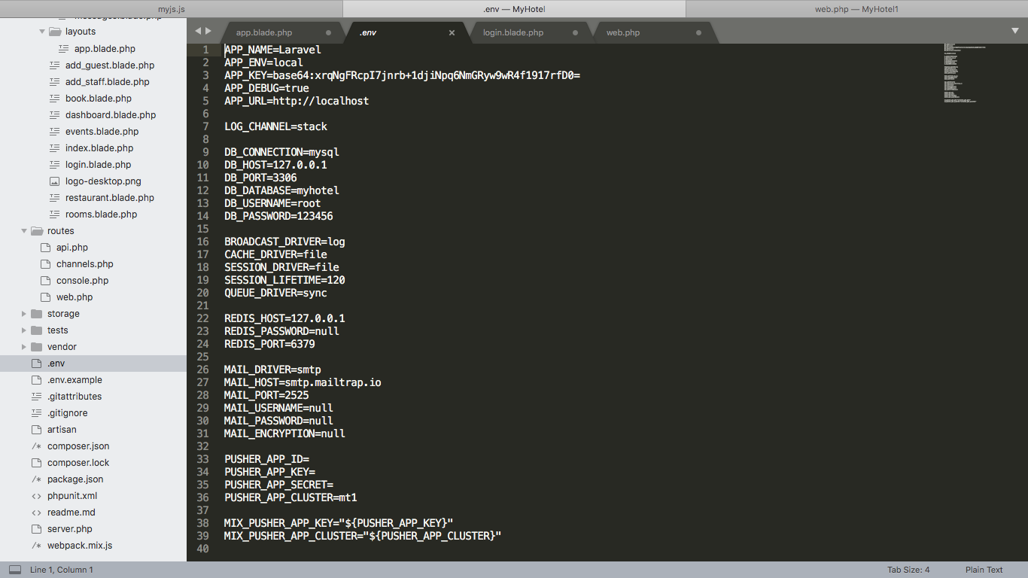

To configure database and such sings we use .env

To enhance and make understandable code we used app.blade.php.

It is created for header and footer part of HTML

Here you can see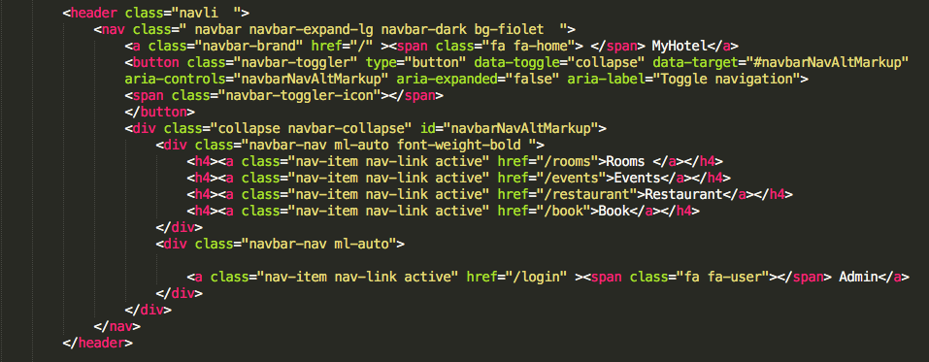

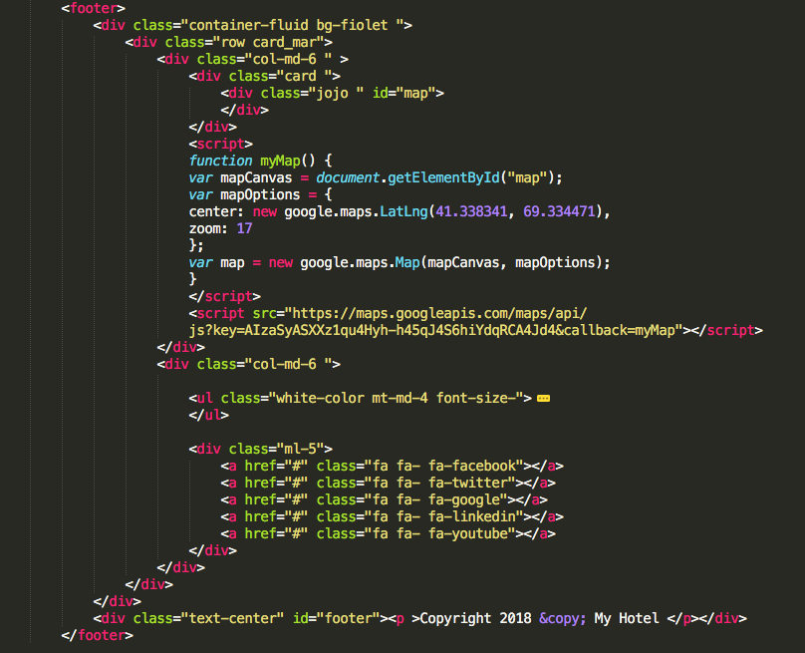

Messages.blade.php

Is for warning messages

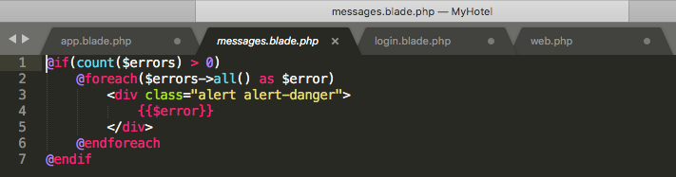

this is whole code of app.blade.php

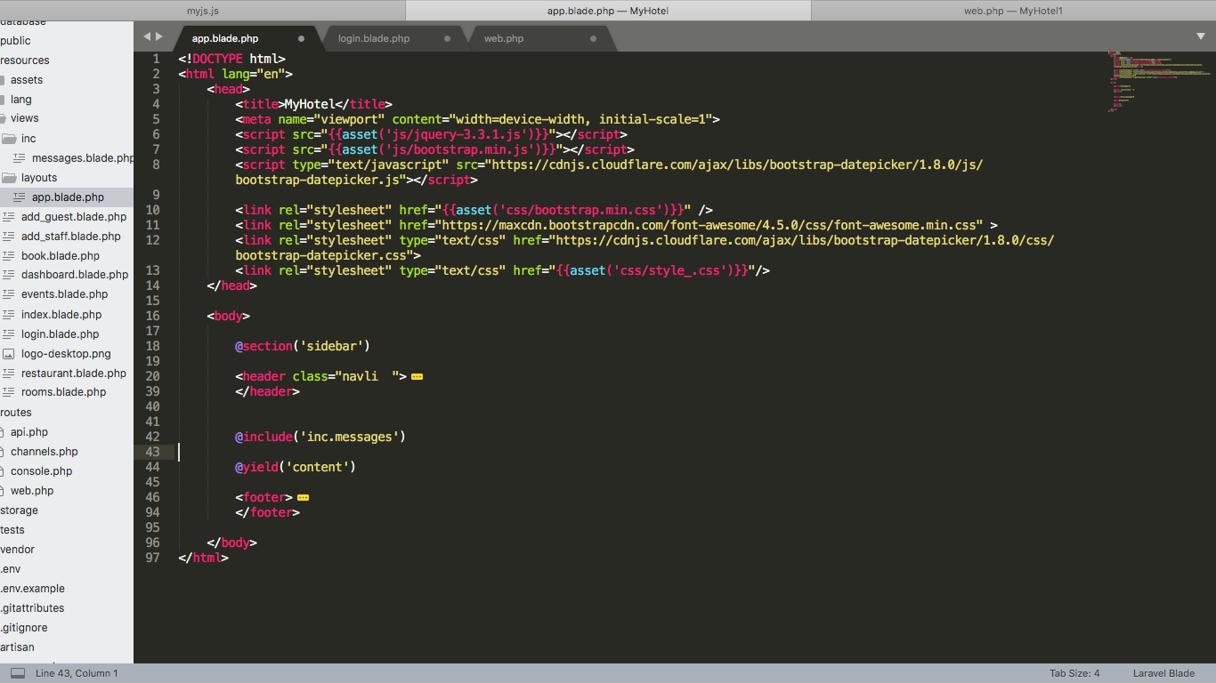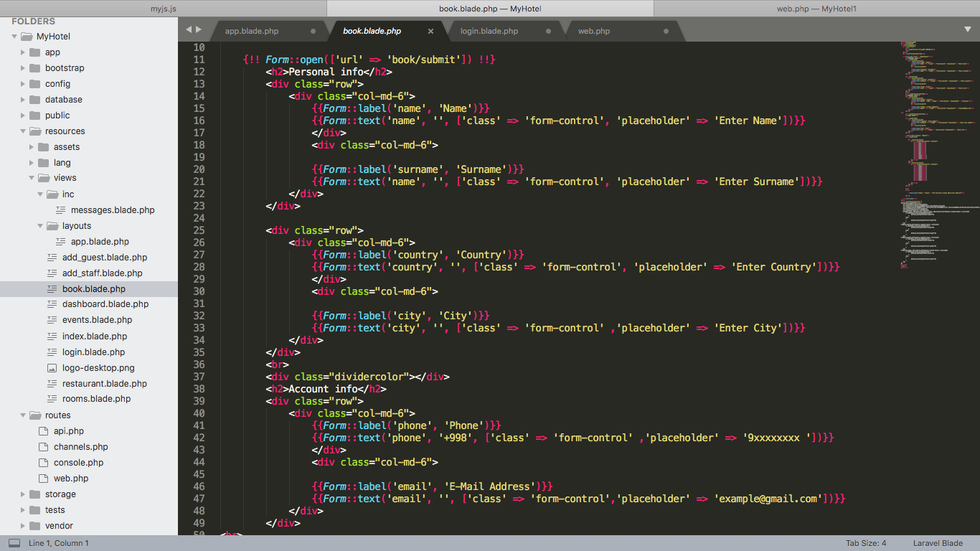

This php is related to book.blade.php, actually it is to book room.

This is admin auth.

